**Report 4**

Natasha Mayorga

COP 3540-002

November 24, 2024

**PART ONE – MongoDB with Restaurants Database**

1. Show the first 5 restaurants which is in the borough Queens.

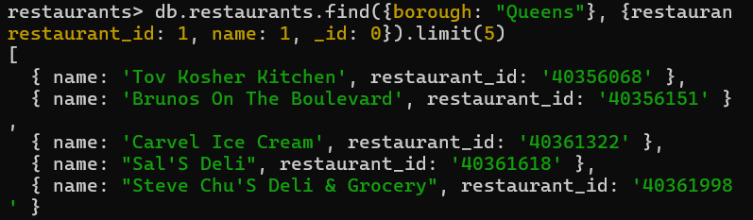

2. Show the restaurants which do not serve any cuisine of 'Chinese' and received a grade point 'B'. The results should be sorted based on cuisine in descending order.

3. Show the fields restaurant_id, name, cuisine and borough, but don’t include _id for the first 5 restaurants.

4. Show the next 5 restaurants after skipping first 5 which are in the Bronx.

5. Show the restaurant_id, name, borough and cuisine for those restaurants which prepared dish except 'American' and 'Chinese'.  
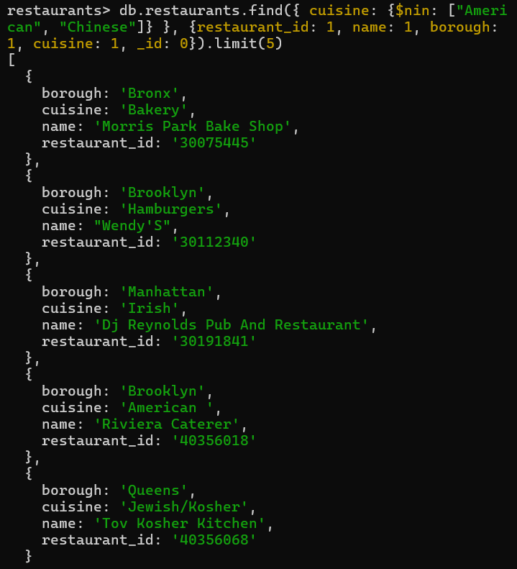

6. Show the restaurants that achieved a ‘score’, more than 70 but less than 90.

7. Show the restaurant_id, name, and cuisine for those restaurants which belong to the borough Manhattan or Queens or Bronx.

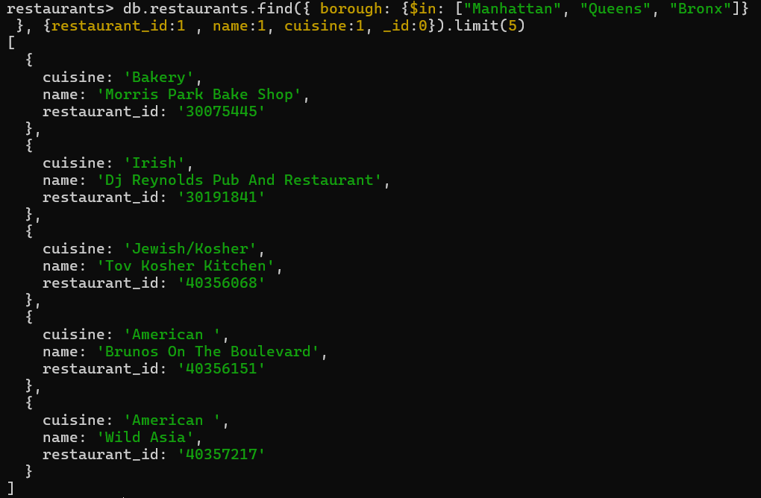

8. Show the restaurants which locate in latitude value less than -93.

9. Show the restaurant_id, name and grades for those restaurants which returns 0 as a remainder after dividing the score by 7.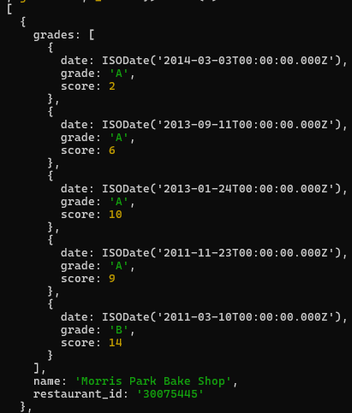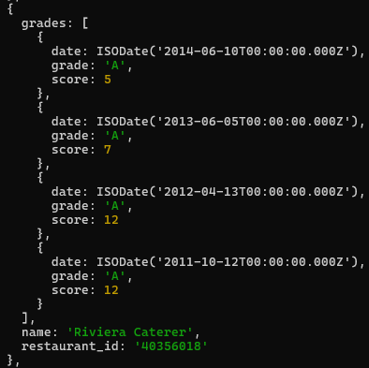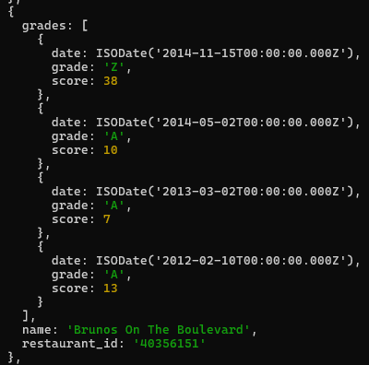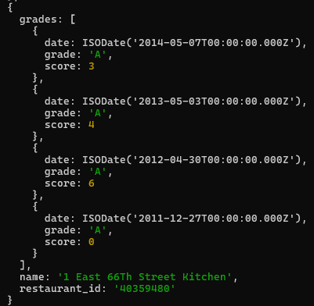

10. Write a MongoDB query to find the restaurants that have at least one grade with a score of less than 5 and that are located in the borough of Manhattan or Brooklyn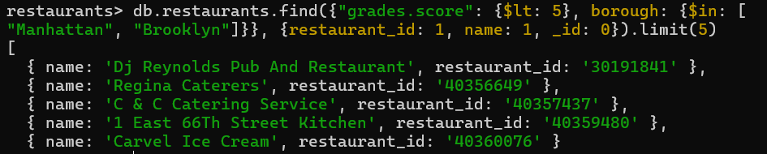

11. Write a MongoDB query to find the name, address, and grades of the restaurants that have at least one 'A' grade and no 'C' grades.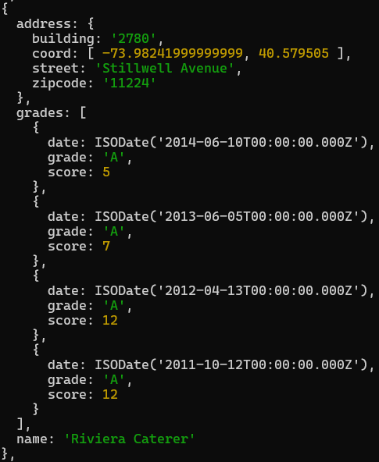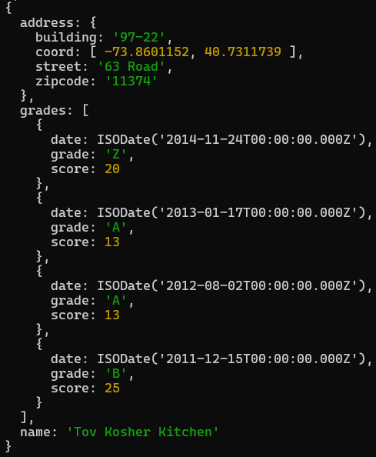

12. Write a MongoDB query to find the name, address, and grades of the restaurants that have at least one 'A' grade, no 'B' grades, and no 'C' grades.

**PART TWO – MongoDB with Your Own Table**

*Note: some entries in clients table not included in screenshots for brevity*

**QUERIES:**

1. **PROJECTION:** Retrieve the name and location fields for all clients, excluding the _id field  
   A computer screen shot of a black screen with white text

   Description automatically generated
2. **COMPARISON:** Find all clients whose client_id is greater than 10

1. **$and and $or:** Find all clients where the city is either "New York" or "San Francisco" and the payment_terms is Net 30

1. **$all:** Find clients where the recent_invoices array contains 800, 1200, and 750

1. **$elemMatch:** Find all clients where the recent_invoices array contains at least one invoice greater than 5

1. **UPDATE:** Update the payment_terms field to "Net 60" for the client with client_id 5A black screen with yellow text

   Description automatically generated
2. **DELETE:** Delete all clients whose billing_info is "Net 90"



**EXTRA CREDIT**

*Note: some entries in clients table not included in screenshots for brevity*

**QUERIES:**

1. **PROJECTION:** Find name, department, and project_history fields for employees

1. **COMPARISON:** Find employees names with an hourly rate greater than 90

1. **$and and $or:** Find employees who either work in the Operations department or have an hourly rate less than 75, but not both

1. **$all**: Find employees who have worked on projects 2 and 6

1. **$elemMatch:** Find employees who have worked on projects after ID 5A computer screen shot of a program code

   Description automatically generated
2. **UPDATE:** Increase the hourly_rate of employees in the Risk department by 10

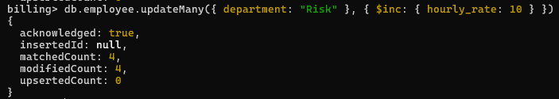

1. **DELETE:** Remove employees who have not worked on any projects

